When you run command “terraform init” it installs alll required plugin.
Terraform providers are distributed by HashiCorp and are publicly availabel in the Terraform Registry at the URL “ registry.terraform.io ”

There are 3 Tiers of providers.
1. Official Providers – These are owned and maintained by HashiCorp & include the major cloud providers such as AWS, GCP, Azure.

2. Partner Providers – Owned and maintained by Third-Party technology company that has gone through a partner provider process with HashiCorp.
Ex. bigip Providers by F5 Network,
Heroku,
DigitalOcean etc.
3. Community Providers – Thar are published and maintained by individual conrtibutors of the HashiCorp community.

The Plugins are downloaded into a hidden directory “ ‘working directory’/.terraform/plugins” in the working directory containing the configuration file.

The Plugin names you see here , that “ hashicorp/local ” is also known as source address.
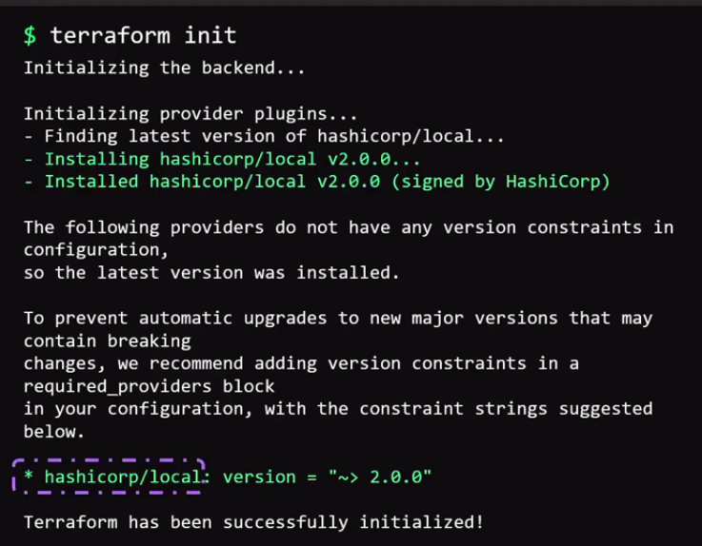
This is an identifyer that is used by Terraform to locate and Download the plugin form the registry.

Here, hashicorp is the organizational namespace,

Local – name of the provider
Providers are AWS, AzureRM , Google, Random etc.

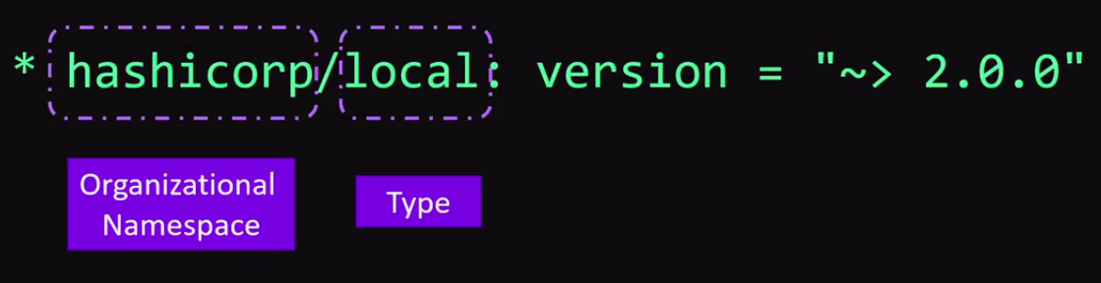

The Plugin name can also have a hostname in front.
The Hostname is the name of the registry where the plugin is located.

It is defaults to “ registry.terraform.io ”
This is HashiCorp’s public registry.

Local provider is stored in the public terraform registry within the HashiCorp namespace
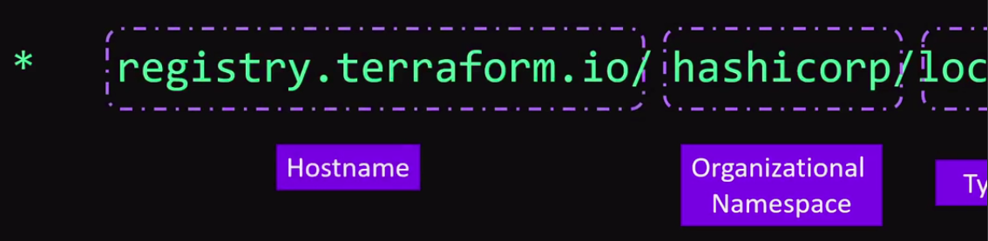

Source Address is -- registry.terraform.io/hashicorp/local

